Chapter 12, Problem 15.

The circuit in Fig. 12.48 is excited by a balanced three-phase source with a line voltage of 210 V. If Z_{l} = 1 + j1 Ω, Z_{Δ} = 24 - j30 Ω, and Z_{Y} = 12 + j5 Ω, determine the magnitude of the line current of the combined loads.

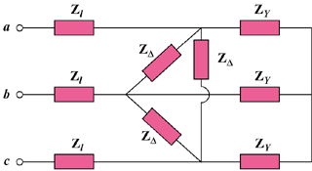

Figure 12.48
For Prob. 12.15.

